Amazon VPC Routing
Main route table
- When you create a VPC, AWS automatically creates a main route table.
- A route table contains rules (routes) that determine where network traffic is directed.
- By default, the main route table allows traffic between all subnets in the VPC (local communication).
- You cannot delete the main route table.
- You cannot set a gateway route table as the main route table.
- You can replace the main route table with a custom subnet route table.
- You can add, remove, or modify routes in the main route table.
- You can explicitly associate a subnet with the main route table, even if it’s already implicitly associated.

Custom route tables
- Subnets without an explicit route table association use the main route table by default.
- You may want different routes per subnet to control access to resources outside the VPC.
- Example: Separate subnets for frontend and database can have different routes.
- If a subnet is associated with a custom route table, it uses that instead of the main route table.
- Each custom route table already includes the local route, allowing communication between all subnets in the VPC.
- You can enhance VPC security by associating new subnets with custom route tables and keeping the main route table unchanged.
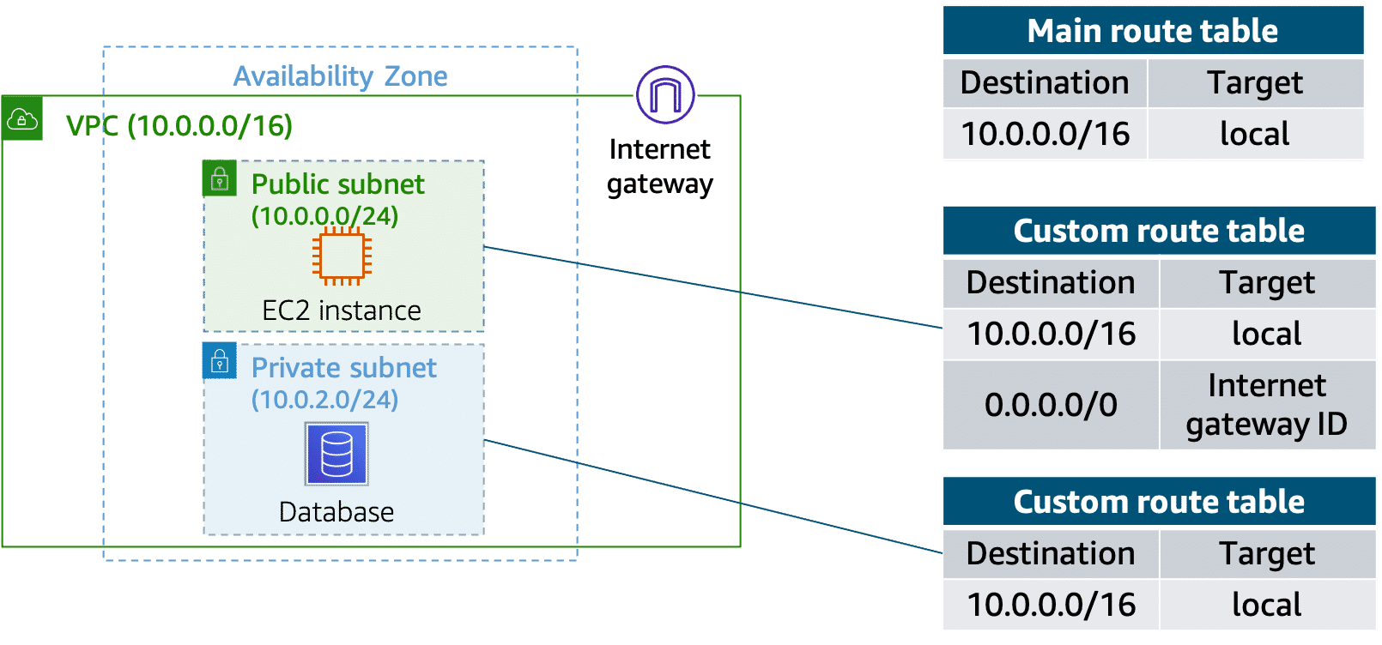

Resources
For more information, see the following resource:
(opens in a new tab)(opens in a new tab)
- AWS user guide: Configure Route Tables

